## CHEMICAL FUELS

Introduction, Classification, Gross Calorific value and Net Calorific value. Solid fuel (coal) – proximate & ultimate analysis. Liquid fuels: Petroleum-Refining, Cracking and reforming. Synthetic Petrol: Methods of production. Gaseous fuels: bio-gas production and uses.

## Learning objectives

* Define calorific value and describe the classification of fuels
* Understand the terms NCV and GCV
* To know about the petroleum refining, cracking and reforming techniques
* Understand about Synthetic fuels, production process
* To know about the production of bio-gas and their uses

## Introduction

Chemical fuel is a carbonaceous material which on proper combustion in air releases a large amount of heat which can be used for both domestic and industrial purposes economically. Eg. Wood, charcoal, coal, kerosene, petrol, diesel, producer gas, water gas, natural gas, etc. The main elements invariably present in chemical fuels are C, and

H. During combustion, C and H of the chemical fuel combine with the oxygen from the air to form CO2 and H2O respectively. Chemical fuels release heat during combustion as the heat content of combustion products (CO2 & H2O) are lower than that of the reactants (C, H of the fuel). The combustion process can be explained in terms of the three components - temperature, time and turbulence. *Temperature* – To have good combustion, the temperature must be high enough to ignite the fuel constituents and all the gases that are released during the process.

*Time* – The time (reaction period) must be sufficient to complete the combustion process. *Turbulence* – There should be sufficient turbulence to allow complete mixing of combustible elements, fuel, and oxygen. The sustainability of fire depends upon a favorable fuel-oxidant ratio and the maintenance of temperature above ignition temperature. The three components of fire involved in a fuel such as wood, kerosene or gas, energy sufficient to support combustion and an oxidizing agent like air.

## Classification of fuels

Fuels may generally be classified in two ways as follows;

1. Based on occurrence – Primary (natural) and secondary (derived/man-made/synthetic) fuels.
2. Based on the physical state – Solid, liquid and gaseous fuels.

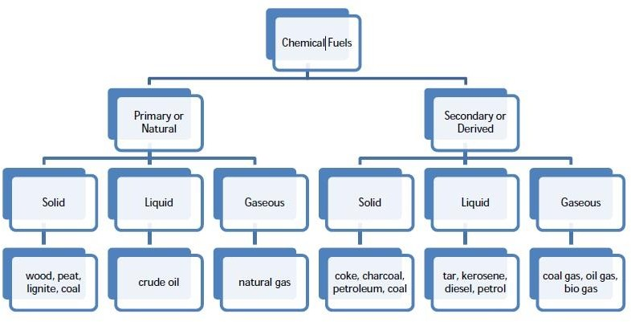

## Calorific value

The calorific value is the amount of heat or energy produced when the substance is allowed to undergo combustion. It is an important property of fuel and is defined as “the amount of heat liberated when unit mass (or unit volume in gaseous fuel) of fuel is completely burnt with pure oxygen”. In the case of solid or liquid fuels, the weight sufficiently defines the quantity of the fuel present. However, in the case of gaseous fuels, it is necessary to specify both temperature and pressure to define this quantity. The calorific value is generally expressed in calorie per gram (cal/g), kilocalorie per kilogram (kcal/kg) or joule per kilogram (J/kg) in case of solid and liquid fuels. In case of gaseous fuels, the units used are kilocalorie per cubic meter (kcal/m3) or joules per cubic meter (J/m3). It is measured either as gross or net calorific value; the difference is given by the latent heat of condensation of the water vapor produced during the combustion process.

## Gross or Higher calorific value (GCV /HCV)

The Gross or Higher calorific value is defined as “the amount of heat liberated when unit mass/volume of the fuel is burnt completely in oxygen, and the products of combustion are cooled to room temperature”. When a fuel containing carbon and hydrogen is burnt, C and H are converted into CO2 and water vapor. Latent heat of steam is released, and water vapor condenses to form water when the combustion products are cooled to room temperature. GCV is higher than NCV as it includes latent heat of condensation of steam.

## Net or Lower calorific value (NCV / LCV)

Net or Lower calorific value is defined as “the amount of heat produced when unit mass/volume of fuel is completely burnt in air, and the products of combustion are allowed to escape into the atmosphere”. In actual practice, the combustion products (steam) are not cooled to room temperature but simply let off into the atmosphere. Hence, a lesser amount of heat is available. Since this calorific value does not include the latent heat of condensation of steam, the net calorific value is always lower than gross calorific value.

NCV = GCV – Latent heat of condensation of steam

= GCV – Mass of hydrogen × 9 × latent heat of steam

= GCV – 9 x % of hydrogen × latent heat of steam 100

NCV = GCV – 0.09 × % H ×587

[Note: Because1g hydrogen gives 9g of water] If H = Percentage of hydrogen in fuel, then,

Water formed by combustion of 1g of fuel = 18 x H = 0.09H g

2 100

[Latent heat of steam is 587cal/g]

The calorific value of a chemical fuel is determined experimentally using Bomb and Boy’s calorimeter. The bomb calorimeter is used for the determination of the calorific value of solid and liquid fuels whereas Boy’s calorimeter is used for gaseous fuels.

## Solid fuels

Solid fuels are primarily classified into two; Natural fuels- wood & coal

Manufactured fuels- charcoal & coke.

### Advantages

1. Easily transportable.
2. Conveniently stored without risk of any spontaneous explosion.
3. Low production cost.
4. Possess moderate ignition temperature.

### Disadvantages

1. High ash content.
2. Wastage of large proportion of heat.
3. Clinker formation when they burn.
4. Combustion process cannot be easily controlled.
5. High handling cost.

The main solid fuels include wood, peat, lignite, coal, and charcoal.

### Applications:

Used for many years to create fire.

Coal - a fuel source that aided the industrial revolution

Wood - used to run steam locomotives. Peat and coal – Currently used in the generation of electricity

Charcoal is prepared by the dry distillation of wood. It is the best fuel since it has no sulfur content. But it is costly Coke is obtained by destructive distillation of soft coals in closed retorts. Briquetted coal is obtained by briquetting the dried coal by applying pressure alone. Pulverised coal is obtained by pulverized the low-grade fuels.

## Analysis of coal and its significance

The proximate analysis involves the determination of moisture, volatile matter, ash, and fixed carbon. This gives quick and valuable information about classification and suitability. The ultimate analysis involves the determination of carbon, hydrogen, sulfur, nitrogen, oxygen, and ash.

The ultimate analysis is essential for calculating heat balances.

## Proximate analysis of coal

1. ***Moisture:*** About 1 g of air-dried finely powdered sample of coal is weighed into a dry silica crucible and heated for about one hour at 110 0C in an electric hot air-oven. The crucible is cooled first in the air, then in a desiccator and weighedW. The loss in weight is noted.

% of moisture = Loss in weight X 100

Wt. of coal sample

During the burning of coal, moisture in it evaporates by taking some liberated heat in the form of latent heat of evaporation, thereby lowering the effective calorific value of coal. Hence, lesser the moisture content better is the quality of coal as a fuel. But, the presence of up to 10% moisture creates more uniform fuel-bed and less of “fly-ash”.

1. ***Volatile matter***: The dried coal sample left in the crucible in step (i) is then covered with a lid and placed in a muffle furnace, maintained at 950 ± 200 oC. The crucible is taken out after 7 minutes of heating. It is cooled first in air further in a desiccator and finally weighed.

% of volatile matter = Reduction in weight due to loss of volatile matter X 100

Wt. of coal sample

Higher % of the volatile matter in coal is undesirable as a high proportion of fuel will distill over as vapor and a large portion of which escapes unburnt. Coal sample with high % volatile matter

burns with a long flame, high smoke and has low calorific value. Coal is ranked good if the volatile matter is less.

1. ***Ash****:* The residual coal left in the crucible in step (ii) is heated without the lid in a muffle furnace at 700-750 oC, until a constant weight of residue is obtained.



The mineral matter originally present in the vegetable material from which the coal was formed, consists of oxides of K, Mg and Ca and is called intrinsic ash. Non-essential mineral matters such as clay, gypsum or other inorganic matters, give rise to extrinsic ash. The intrinsic ash content rarely exceeds 1 to 2% whereas extrinsic ash content is relatively higher.

Ash-forming constituents in coal are undesirable for the following reasons:

1. The calorific value of the coal is decreased
2. Removal and disposal of ash poses problems
3. The ash deposited in the fire bars interferes with the circulation of air
4. If the ash fuses to form a clinker on the fire bars, it hinders air circulation and also promotes corrosion of the fire bars. However, some ash is desirable since it serves to protect the grates from direct contact with incandescent coal, which might lead to oxidation of the grate bars.

**(iv) *Fixed carbon****:* It is reported as the difference between 100 and the sum of the percentages of moisture, volatile matter and ash content of a coal sample.

Calorific value and quality of a coal sample increase with the percentage of fixed carbon. Greater the percentage of fixed carbon, smaller is the percentage of volatile matter. It is the fixed carbon which burns in the solid state. Hence information regarding the percentage of fixed carbon helps in the designing of the furnace and the fire-box.

***Significance:*** Grading of a coal or coke sample to determine moisture, volatile matter, fixed carbon, and ash are done by proximate analysis which is important to both the suppliers and users to have a speedy, precise and consistent procedure. It also helps to;

1. Rank coal
2. Show the quantity of combustible and non-combustible constituents
3. Provide the basis for buying/selling,
4. Identify appropriate coal for different purposes.

## Ultimate analysis of coal

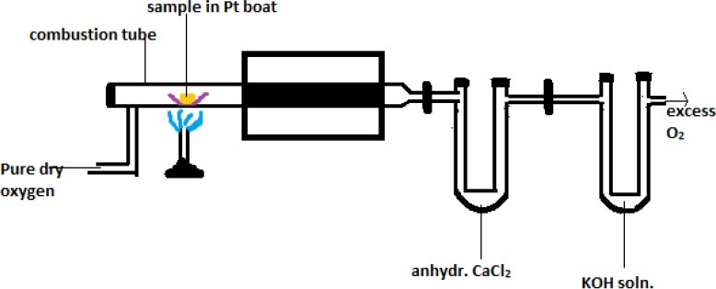**(i) *Carbon and hydrogen***: An accurately weighed coal sample (1-2 g) is burnt in a current of oxygen in a combustion apparatus. As a result, carbon and hydrogen of the coal are converted into CO2 and H2O respectively. These are absorbed respectively in weighed KOH and CaCl2 tubes. The rise in the weights of KOH and CaCl2 tubes corresponds to the amount of CO2 and H2O formed respectively.

**Fig**. Schematic diagram of % C & % H analysis

C + O2 → CO2 H2 + ½ O2 → H2O

12 44 2 18

2 KOH + CO2 → K2CO3 + H2O CaCl2 + 7 H2O → CaCl2 .7 H2O

% of carbon = Increase in weight of KOH tube X 12 X 100

Wt. of coal taken X 44

% of hydrogen = Increase in weight of CaCl2 tube X 2 X 100

Wt. of coal taken X 18

Carbon and hydrogen in coal directly contribute towards the calorific value of the coal. Greater the percentage of C and H, better is the coal quality and higher is its calorific value.

**ii) *Nitrogen****:* The percentage of nitrogen is determined by digesting a known quantity (1 g) of powdered air-dried coal sample with Conc. H2SO4 and HgSO4 in a Kjeldahl’s flask using K2SO4 as a catalyst. After the solution becomes clear, excess NaOH is added and the ammonia liberated is distilled into a known volume of acid solution of known strength. The volume of unused acid is determined by back titration using standard NaOH solution. The percentage of nitrogen is calculated from the volume of acid neutralized by ammonia liberated, The Kjeldahl’s apparatus is shown in Fig.

Nitrogen in the coal does not contribute any useful value to the coal, and since it is generally present in small quantities (~ 1%), its presence is not of much significance. However, the nitrogen content is less in good quality coal.

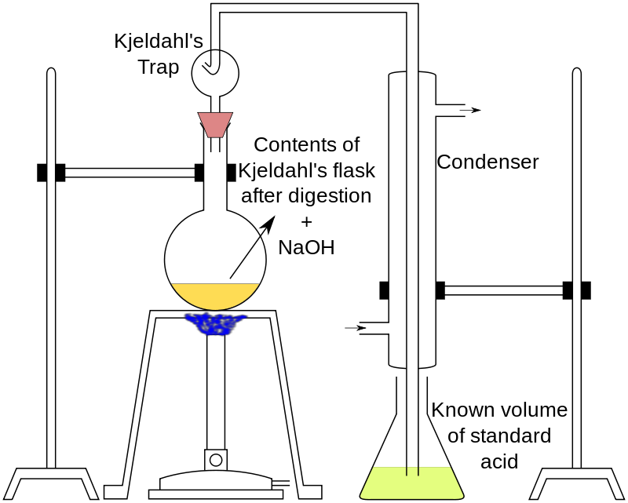

**Fig.** Schematic diagram of Kjeldahl apparatus

% of nitrogen = Weight of nitrogen X 100

Wt. of coal taken

Where, Weight of nitrogen = Volume of acid used X Normality of acid X 14

1000

Thus, % of nitrogen = Vacid X Nacid X 1.4

Wt. of coal taken

1. ***Sulfur***: Weighed coal sample is allowed to undergo complete combustion in a bomb calorimeter by which sulfur present in coal is oxidized to sulfates. The ash left after combustion from the bomb calorimeter is extracted with dil. HCl. Barium chloride solution is added to the acid extract barium sulfate, which is then filtered, washed, ignited and weighed. From the weight of barium sulfate obtained the sulfur present in the coal is calculated.

% of sulfur = Wt. of BaSO4 obtained X 32 X 100

Wt. of coal taken X 233

Sulfur present in coal adds to the calorific value of the coal, but its combustion products (SO2 and SO3) have corrosive effects on equipment, particularly in the presence of moisture. Further, the oxides of sulfur are undesirable from the atmospheric point of view. Sulfur-containing coal is not suitable for the preparation of metallurgical coke as it adversely affects the properties of the metal.

1. ***Ash***: The ash content of the coal sample is determined as described under proximate analysis.
2. **Oxygen**: The oxygen content is calculated by difference as follows:

Percentage of oxygen = 100 – Percentage of (C + H + N + S + Ash)

The oxygen content of coal is generally associated with moisture. The lower the oxygen content, the more is the maturity of coal, and greater is its calorific value. As the oxygen content increases, the capacity of the coal to hold moisture increases and the coking power decreases.

### Significance

To evaluate the chemical composition of coal in terms of various elements present (C, H, O, N,

S) and ash

To predict the suitability of coal for the purpose of heating For combustion calculations

To determine the composition of flue gases

## Numerical problems

1. About 0.6 g of a coal sample was allowed to undergo combustion in a bomb calorimeter. The calorific value of the sample was found to be 8600 cal/g. The ash formed was extracted with acid, and this was heated with BaCl2 solution. The weight of dried barium sulfate obtained was found to be

0.05 g. Calculate the % of S in the coal sample.

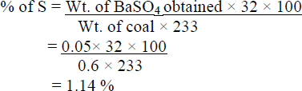

1. 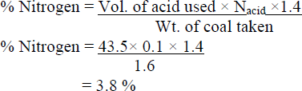About 1.6 g of coal sample was kjeldahlised and NH3 gas thus evolved was absorbed in 50 mL of 0.1 N sulphuric acid. After absorption, the excess of acid required 6.5 mL of 0.1 N NaOH for neutralization. Calculate the % of nitrogen in the sample.

## Liquid fuels

Liquid fuels are combustible molecules that can be harnessed to create mechanical energy. They are predominantly used in industries. Most liquid fuels used currently are made from crude petroleum. Gasoline is the most widely used liquid fuel. Liquid fuels have the advantage of higher calorific value per unit mass compared to solid fuels, burn without dust, ash & clinkers and are

easy to transport through pipes. But liquid fuels are costlier than solid fuels and possess greater fire hazard risks (especially highly inflammable & volatile liquid fuels).

## Petroleum

Petroleum was formed in nature by anaerobic decay of marine plant and animal life under high temperature and pressure millions of years ago. It is a complex mixture of organic crude oil and natural gas which consists of hydrocarbons like paraffins, cycloparaffins, olefins, and aromatics with small quantities of nitrogen, oxygen, and sulfur-containing organic compounds and traces of inorganic compounds. The process of separation of crude oil into different useful fractions on the basis of their boiling points using an efficient bubble cap type fractionating column is called petroleum refining.

## Cracking

An average grade crude oil on fractionation yields about 20-30 % gasoline, 30-45 % intermediate oils and 25-50 % residual fuel oils. Cracking of the surplus heavier fractions gives greater yields of improved gasoline and better engine performance than that obtained from fractional distillation of crude oil. Cracking is defined as the process of decomposition of hydrocarbons with higher molecular weight into that of lower molecular weight by breaking C-C and C-H bonds producing low boiling alkanes and alkenes.

Cracking

## C10 H22 C5H12 + C5H10

## (Decane) High b.p (pentane) (Pentene) Low b.p

## Types of Cracking:

1. Thermal Cracking 2) Catalytic Cracking

Thermal Cracking: In thermal cracking high temperatures and pressures are used to break the large hydrocarbons into smaller ones. Thermal cracking gives mixtures of products containing high proportions of hydrocarbons with double bonds- alkenes. •Thermal cracking doesn’t go via ionic intermediates like catalytic cracking. Instead, carbon-carbon bonds are broken so that each carbon atom ends up with a single electron. In other words, free radicals are formed

## Catalytic Cracking:

* Modern cracking uses Zeolites as the catalyst. These are complex aluminosilicates and are large lattices of aluminum, silicon and oxygen atoms carrying a negative charge. They are, of course, associated with positive ions such as sodium ions. You may have come across a zeolite if you know about ion exchange resins used in water softeners.
* The alkane is brought into contact with the catalyst at a temperature of about 500 oC and moderately low pressures.
* The zeolites used in catalytic cracking are chosen to give high percentages of hydrocarbons with between 5 and 10 carbon atoms- particularly useful for petrol. It also produces high proportions of branched alkanes and aromatic hydrocarbons like benzene.
* The zeolite catalyst has sites which can remove hydrogen from an alkane together with the two electrons which bound it to the carbon. That leaves the carbon atom with a positive charge. Ions like this are called carbonium ions. The reorganization of these leads to various products of the reaction.

## The main advantages of catalytic cracking are as follows

* The octane number and yield of gasoline produced is high.
* The process can be better controlled.
* There is a saving in production costs as high temperatures, and high pressures are not required.
* External fuel is not required. The necessary heat is obtained by burning off the coke deposited on the catalyst itself, during the regeneration process.
* Catalysts are selective in their action, and therefore, they permit cracking of only high boiling hydrocarbons.

**Catalytic Reforming:** Process of upgrading gasoline by increasing its octane number in the presence of a catalyst. The main reactions taking place during catalytic reforming process are:

* 1. ***Isomerisation*:** Conversion of straight chain hydrocarbons into branched chain hydrocarbons.

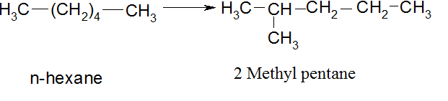

* 1. ***Dehydrogenation:*** Dehydrogenation of cycloalkanes to produce aromatic compounds.

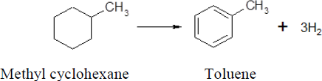

* 1. 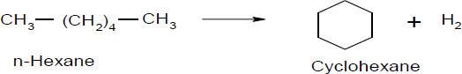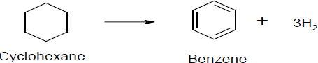***Cyclisation and dehydrogenation*:** Straight chain hydrocarbons undergo cyclisation followed by dehydrogenation to produce aromatic hydrocarbons
  2. ***Hydrocracking*:** n-Paraffins undergo cracking in the presence of hydrogen and catalyst to produce light gases that are removed from gasoline fraction.

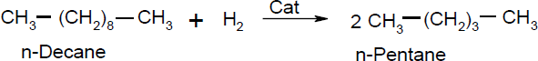

## Synthetic Petrol

Synthetic fuel or Synfuel is a liquid fuel obtained from coal, natural gas, oil shale, or biomass. It may also refer to fuels to fuels derived from other solids such as plastic or rubber waste. It may also refer to gaseous fuels produced similarly. A common use of the term synthetic fuel is to describe fuels manufactured via Fischer Tropsch conversion, methanol to gasoline conversion or direct coal liquefaction.

## Method of producing Synthetic Petrol:

1. Polymerisation
2. Fischer-Tropsch method
3. Bergius process

**Fischer- Tropsch Process**: The Fischer-Tropsch process is a collection of chemical reactions that convert a mixture of carbon monoxide and hydrogen into liquid hydrocarbons. The process, a key component of gas to liquids technology, produces a synthetic lubrication oil and synthetic fuel, typically from coal, natural gas or biomass. The F-T process has received intermittent attention as a source of low sulfur diesel fuel and to address the supply or cost of petroleum-derived hydrocarbon. The water gas is varied with hydrogen, and the combination is purified by transitory from side to side Fe2O3 and then into a mixture of Fe2O3+Na2CO3. The cleanse gas is dense to 5 to 25 atm and then led from side to side a converter, which is preserved at a temperature of 200- 300 oC. The converter is provided with a catalyst bed consisting of a mixture of 1000 parts cobalt, 5 parts thoria, 8 parts magnesia and 200 parts keiselghur earth.

nCO + 2nH2 = CnH2n+ nH2O

nCO +(2n+1)H2 = CnH2n+2 + nH2O

The outcoming gaseous mixture is led to a condenser, where the liquid crude oil is obtained, The crude oil is fractionated to yield gasoline and heavy oil. The heavy oil is used for cracking to get more gasoline.

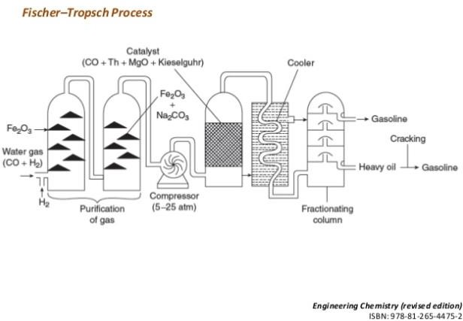

**Fig**. Schematic diagram of Fischer- Tropsch Process

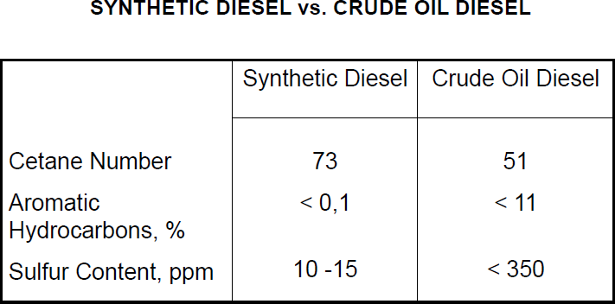

## Gaseous fuels

# Biogas

Biogas is a type of biofuel that is naturally produced by the decomposition of organic waste. When organic matter, such as food scraps and animal waste, break down in an anaerobic environment (an environment absent of oxygen) they release a blend of gases, primarily methane and carbon dioxide. Because this decomposition happens in an anaerobic environment, the process of producing biogas is also known as anaerobic digestion

|  |  |  |
| --- | --- | --- |
| **Compound** | **Formula** | **%** |
| Methane | CH4 | 50–75 |
| Carbon dioxide | CO2 | 25–50 |
| Nitrogen | N2 | 0–10 |
| Hydrogen | H2 | 0–1 |
| Hydrogen sulfide | H2S | 0.1 –0.5 |
| Oxygen | O2 | 0–0.5 |

Biogas digesters receive organic matter, which decomposes in a digestion chamber. The digestion chamber is fully submerged in water, making it an anaerobic (oxygen-free) environment. The anaerobic environment allows for microorganisms to break down the organic material, and convert it into biogas. Biogas is a renewable energy source.

**Bio gas composition**

## Applications

Biogas can be used for electricity production, cooking, space heating, water heating and process heating. If compressed, it can replace compressed natural gas for use in vehicles, where it can fuel an internal combustion engine or fuel cells.

## Summary

In this chapter, the types of fuels based on their origin and physical state and their characteristics are discussed. Chemical fuel is a material that stores chemical energy in forms that can be practically released and used as thermal energy. The calorific value of a substance is the amount of heat released when its specific amount undergoes combustion. Crude petroleum is processed and refined into more useful fractions such as gasoline, diesel fuel, kerosene and liquefied petroleum gas. Quality of gasoline is upgraded through reforming and cracking processes. Synthetic petrol and their production methods are studied. Production of bio-gases and their applications are discussed.

Questions:

1. What is reforming? Explain the vinous reforming processes with relevant reactions.

2. How is percentage of sulphur estimated in a coal sample?